# Visual Studio Code Installation Guidelines

The following information serves as a guide for installing and configuring **Node.js**  и **Visual Studio Code**.   
**Visual Studio Code** is a source code editor which runs on your desktop and is available for **Windows**, **macOS** and **Linux**. It comes with built-in support for **JavaScript**, **TypeScript** and **Node.js** and has a rich ecosystem of extensions for other languages (such as C++, C#, Java, Python, PHP, Go) and runtimes (such as .NET and Unity).

## Part I: Install Node.js

### Download Node.js

Download Node.js from here: <https://nodejs.org/en/download/>

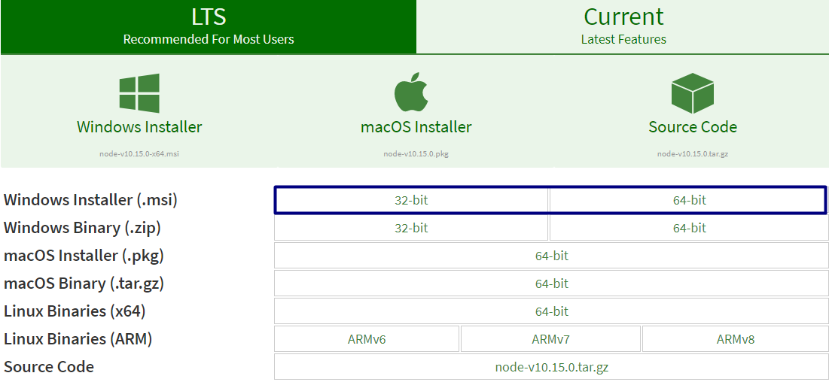

### Install Node.js

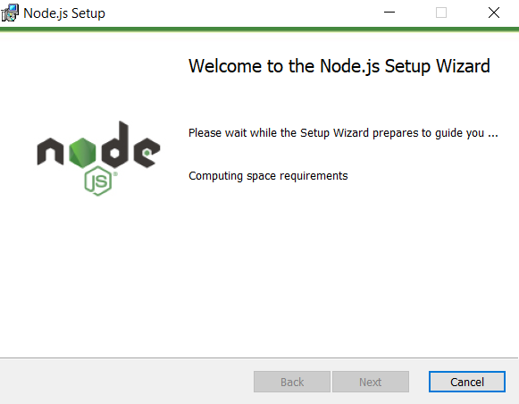

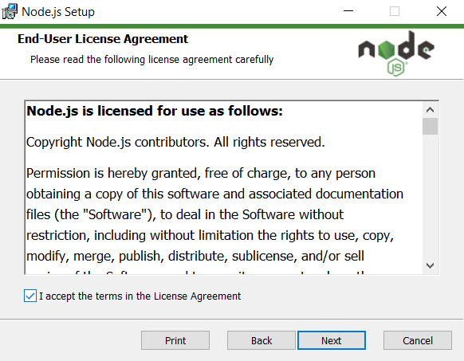

Install **Node.js** in a custom directory.

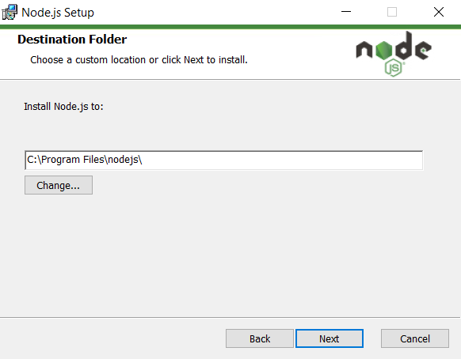

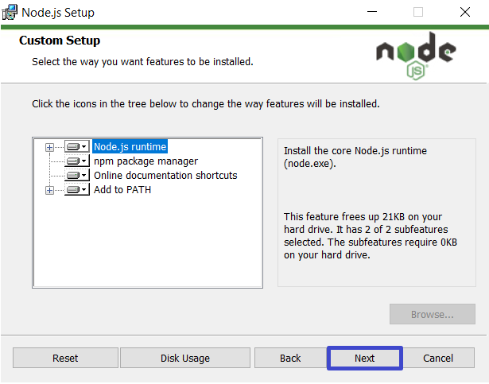

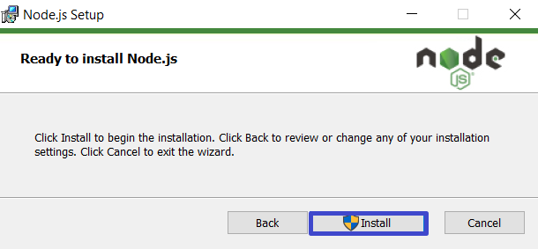

**Important: After a successful installation of Node.js, be sure to restart your computer before proceeding with Part II!**

## Part II: Install Visual Studio Code

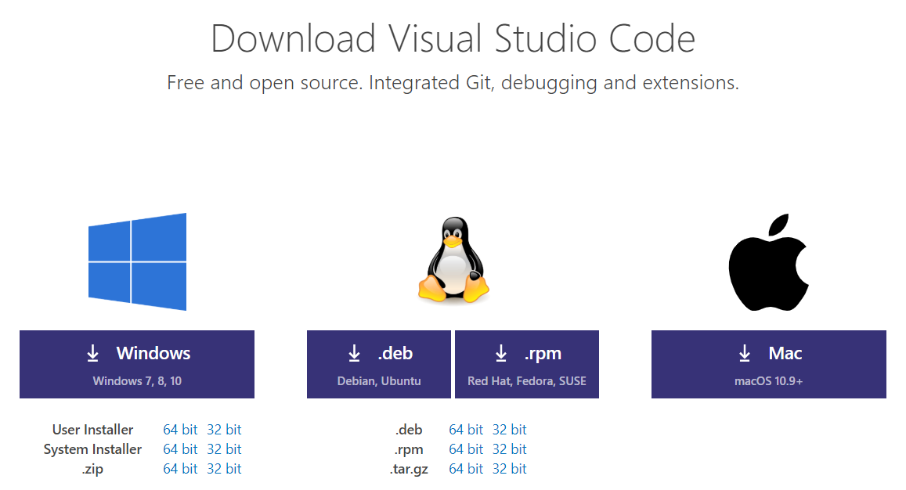

### Download Visual Studio Code

Download the Visual Studio Code installer from: <https://code.visualstudio.com/download>.

### Install Visual Studio Code

The pictures below show the steps required to successfully install **Visual Studio Code** for **Windows 10** and **Windows 11**.

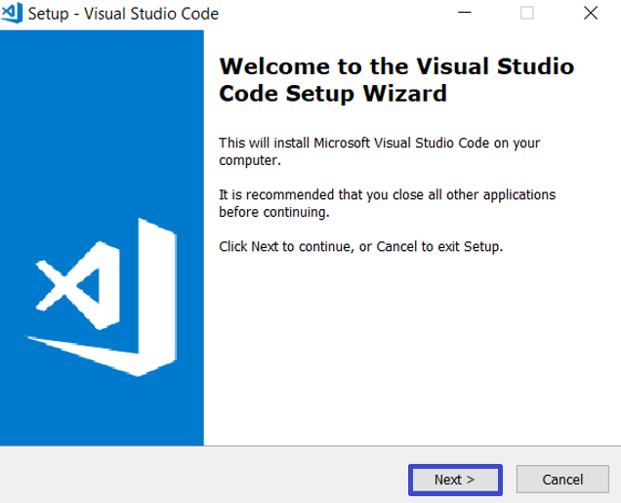

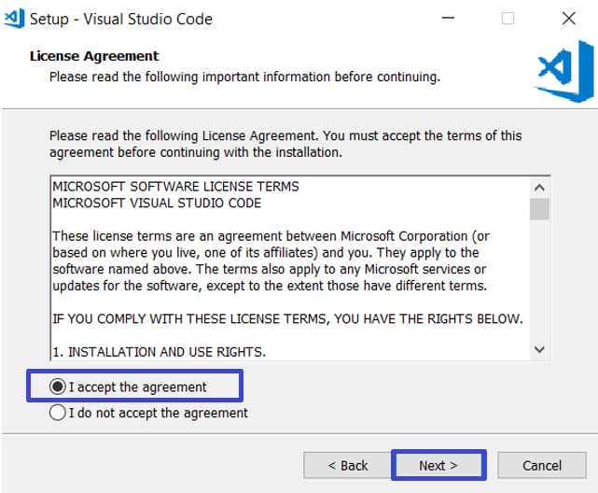

Install **Visual Studio Code** in a custom directory.

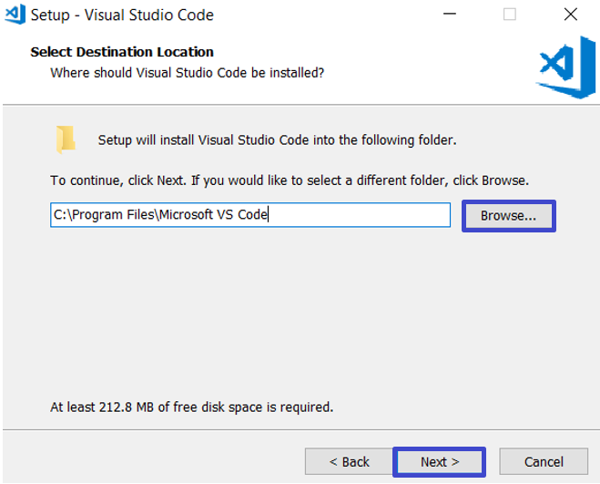

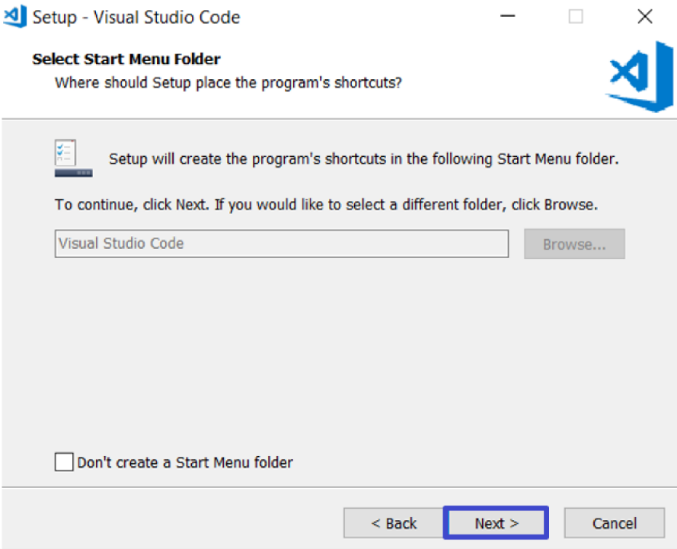

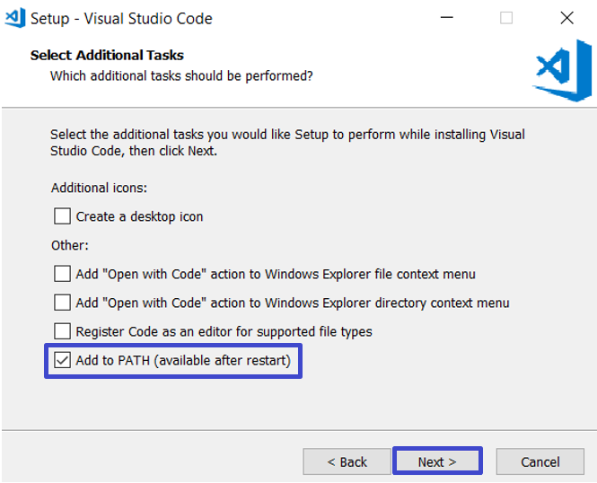

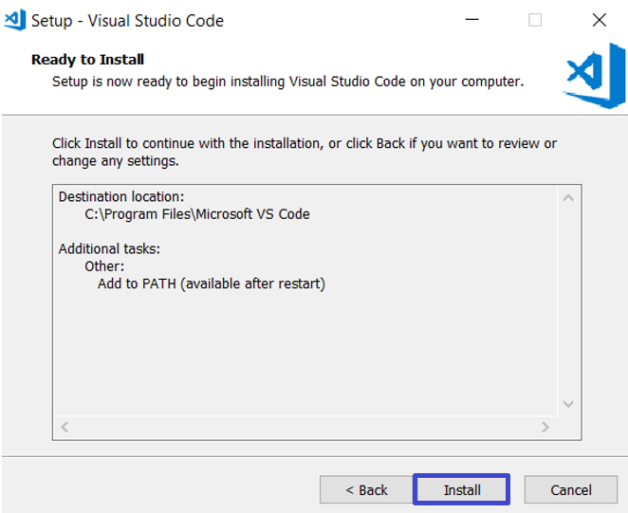

If the installation is successful, you should see the following final screen:

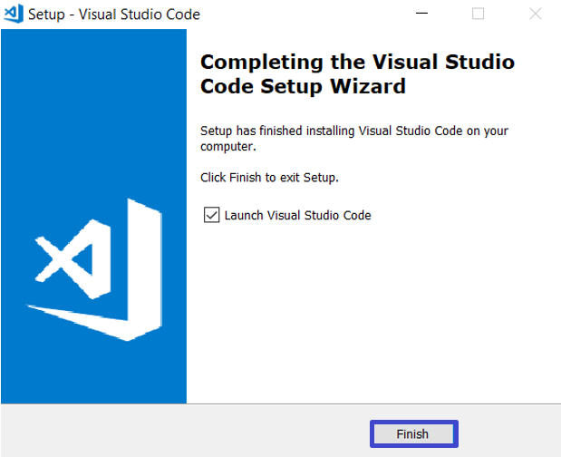

When you start Visual Studio Code, you should see the following window:

